Exploring Momentum and Mean Reversion Techniques for Enhanced SPY Trading Performance

Member: Lizhi Cao, Jiaqi Fang, Shuhan Liao, Xuhan Tong, Xiaoyi Wang, Haobo Yang

- Introduction:
The S&P 500 ETF Trust (SPY) remains one of the world’s most heavily traded and widely held exchange-traded funds. In this project, we investigated and improved the SPDR S&P 500 ETF Trust (SPY) trading strategies by considering momentum, mean reversion, and moving-average strategies. We simulate an extensive backtesting framework that includes volatility normalization, regime filtering, transaction costs, and elaborate risk management improvements. We seek to learn which strategy variants and parameter settings work best through systematic comparison and quantitative analysis, providing valuable data-driven support for trading decisions.
The remainder of the report is organized as follows. Section 2 presents the data sources and related dataset background. Section 3 details the momentum-based models, their backtest results, and enhancements such as volatility scaling and ensemble aggregation. Section 4 focuses on mean-reversion strategies, examining signal thresholds, trade frequency, and robustness analyses across lookback windows. Section 5 explores moving-average crossover approaches, from the canonical fixed-window (50, 100) rule to a full grid search and risk-control augmentations using ATR stops and volatility targeting. In the last section, we will synthesize the key findings, contrast each performance, and outline directions for future research.

- Dataset:

In this project, we used historical daily trading data of the SPDR S&P 500 ETF Trust (SPY), from December 1, 2009, through early 2025, covering approximately 15 years of market activity. The dataset from Yahoo Finance consists of 3,855 observations with seven columns: Date, Adjusted Close, Close, High, Low, Open, and Volume. All data points are complete with no missing values, enabling reliable returns, volatility, and other essential metrics computations.

The dataset columns information:
- Date: Trading dates formatted as YYYY/MM/DD.
- Open: The opening price of SPY is on each trading day.
- High: The highest price of SPY was recorded during each trading day.
- Low: The lowest price of SPY is on each trading day.
- Close: The closing price of SPY is on each trading day.
- Adjusted Close: The closing price is adjusted for dividends and splits, which is critical for accurate return calculations and comparative analyses over time.
- Volume: Total number of shares traded on each trading day.

- Momentum-Based Model:

3.1 Overview:

In this model part, we develop a hierarchy of momentum‑based rules on the SPY ETF (January 2010–March 2025), progressively layering on volatility normalization, regime filtering, transaction‑cost adjustments, alternative momentum definitions, and simple risk controls. For this, we are trying to understand which elements improve risk‑adjusted returns and to recommend a robust, implementable strategy for a mature, high‑liquidity ETF.

Works summary in this part:
- Formalization of a volatility‑adjusted momentum signal and justification of parameter choices.
- Introduction of a volatility‑regime filter to suspend trading in high‑turbulence periods.
- Quantitative assessment of transaction costs on turnover and net performance.
- Comparative analysis of different momentum variants, including mean‑reversion (inverse momentum) and classic trend‑following (moving‑average crossover).
- Evaluation of simple “bolt‑on” enhancements—stop‑loss, EWMA smoothing, leverage scaling, and ensemble—on final performance.

3.2 Data and Preprocessing:

We use daily adjusted close prices $P_{t }$for SPY and compute the following:
- Daily return:
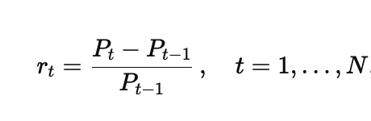
- Raw -day momentum:
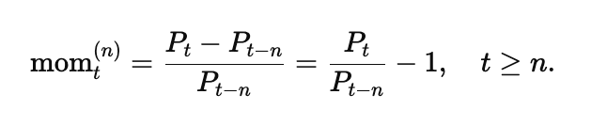

- Rolling volatility(with m-day look‑back):
All signals use data through t-1 to avoid look‑ahead bias.
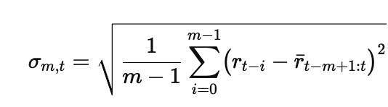

3.3 Regime Filter and Signal Scaling:

We reduce the impact of false momentum signals during turbulent markets by monitoring short-term volatility. Specifically, we compute a 20-day rolling volatility and suspend trading whenever it exceeds its long-run median. We then cap our raw vol‑normalized momentum to the [–1, 1] range by dividing by its 60‑day peak absolute value and clipping, so that our final signal only takes positions when regimes are calm and never exceeds preset leverage limits.
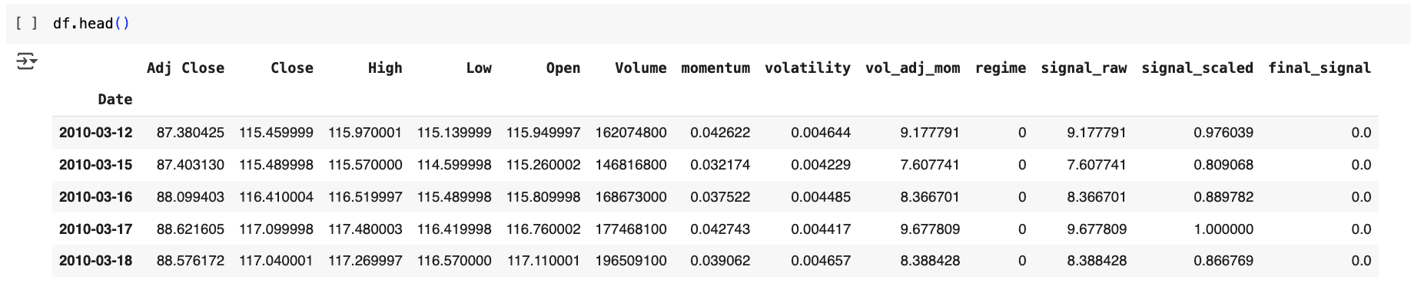

3.4 Backtest Framework:

We simulate an initial capital that $V_{0}$ = $100000. On each day t , we take a position equal to $S_{t-1}$(allowing for fractional leverage). The strategy's daily return is ${{ret}_{t}}^{start}$ = $S_{t-1}$$r^{t}$ and the portfolio value $V_{t }=V_{t-1}(1 +{{ret}_{t}}^{start} )$, where r is the daily return.

We summarize performance over the full sample of N trading days(t = 1,2,3,....N ) to have that
- Total return: $\frac{V_{n}}{V_{0}}-1$
- Annualized return: $(\frac{V_{n}}{V_{0}})^{\frac{252}{N}}-1$
- Annualized volatility: $\sqrt{252} std({{ret}_{t}}^{start})$
- Sharpe ratio: $\frac{Annualized return}{Annualized volatility}$
- Maximum drawdown: min($\frac{V_{t}}{max_{s≤t }V_{s}} - 1$)

3.5 Momentum Variants:

Our base strategy uses a straightforward 10‑day volatility‑adjusted momentum signal. However, financial markets may have short‑term patterns like mean‑reversion, multi‑horizon effects, moving‑average crossovers, and oscillator behavior. For this, we try to implement and compare some alternative momentum‑style rules, all within the same volatility‑normalization and backtest framework, to determine which may improve returns on SPY.
- 3.5.1 Summary:
For m (momentum window) is set to 10 by grid‑search,
let $mo{m_{t}}^{(m)}=\frac{P_{t }- P_{t-m}}{P_{t-m}}$ and $σ_{m,t}=$$\sqrt{\frac{1}{m-1} \sum_{i =0}^{m-1}{}({r_{t-i} - \bar{r})}^{2}}$.
Then each signal $S_{t}$ is as follows
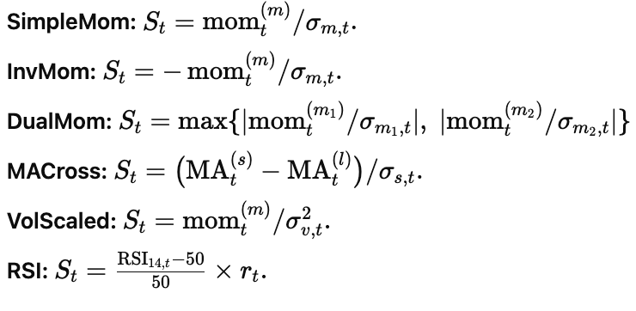
- 3.5.2 Code snippets(Python code on Jupyter notebook):
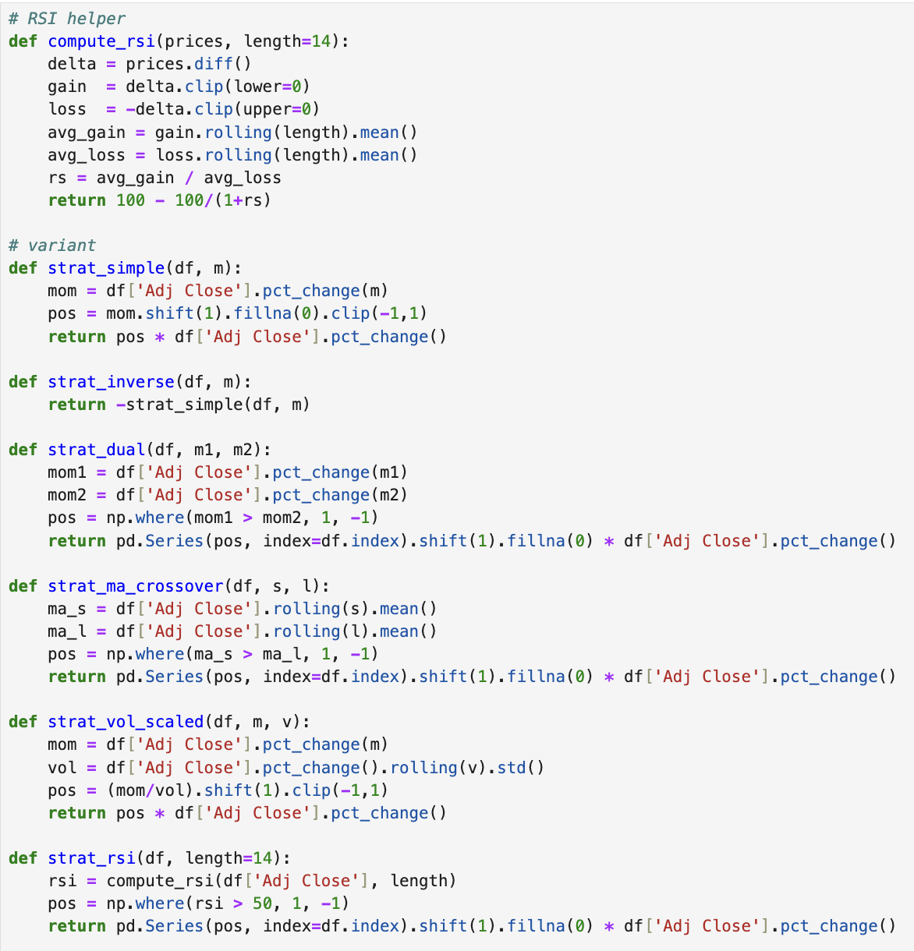
- 3.5.3 Results and observations:
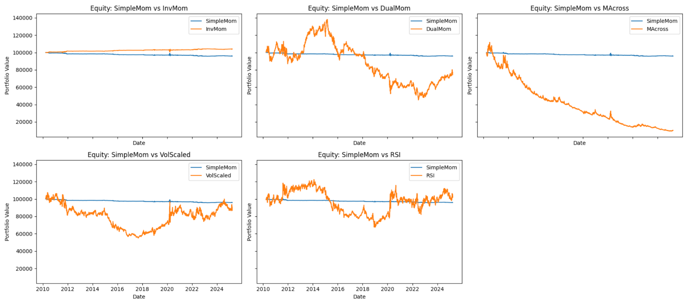
- Dual Momentum vs Simple Momentum: Dual Momentum compares two different momentum lookbacks and takes a position based on which is stronger. The plot shows that Dual Momentum had periods of sharp gains but also deep losses, especially after 2015, leading to large drawdowns. In contrast, Simple Momentum’s equity curve remained relatively flat. Dual Momentum’s instability indicates that switching between different timeframes did not yield consistent gains.
- Moving Average Crossover vs Simple Momentum: The Moving Average Crossover strategy buys when the short-term moving average is above the long-term average and sells otherwise. The plot reveals that this strategy experienced a rapid and continuous decline in capital, performing much worse than Simple Momentum. This suggests that basic crossover signals were ineffective for SPY during this period. This may be due to market noise and whipsaw effects.
- Volatility-Scaled Momentum vs Simple Momentum: This strategy adjusts momentum positions based on rolling volatility, aiming to scale exposure dynamically. The plot shows that although it had some rebounds, Volatility-Scaled Momentum saw large drawdowns and significant capital erosion compared to Simple Momentum. This indicates that while scaling by volatility can control leverage, it didn’t improve returns in this case.
- RSI vs Simple Momentum: The RSI strategy uses the Relative Strength Index (RSI) to generate signals, trading when RSI exceeds a certain threshold (e.g., 50). The plot shows that the RSI strategy had volatile periods with both sharp gains and losses but overall hovered around break-even, slightly better than Simple Momentum. This suggests RSI added some tactical flexibility but did not achieve strong outperformance.
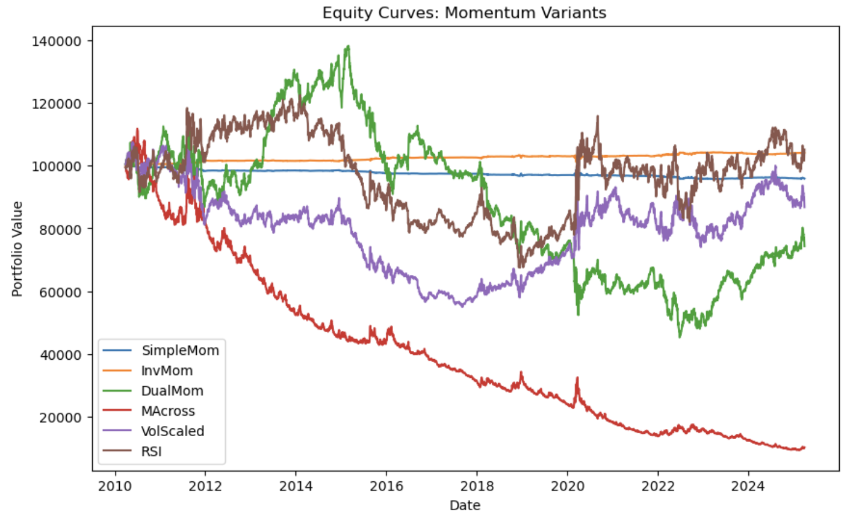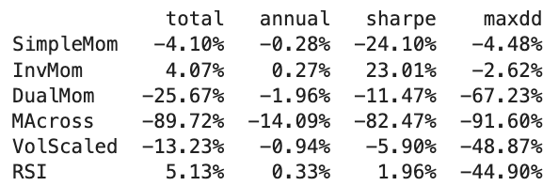
We observed that Inverse momentum (InvMom) and RSI produce the only positive total returns, supporting a mean‑reversion hypothesis for SPY. And, for trend‑following rules (DualMom, MACross), they have severe drawdowns. This reflects poor performance in choppy equity markets. We also observe that volatility-targeted momentum (VolScaled) underperforms, suggesting that over‑leverage in low‑volatility periods can be detrimental without additional risk controls. Overall, while these variants shed light on different momentum flavors, most still lagged passive holding which indicates challenging risk‑adjusted prospects for stand‑alone momentum on SPY over this sample.

3.6 Strategy Enhancements:

After benchmarking our different momentum variants, we test whether simple risk overlays or signal‑combination rules can improve the baseline momentum (SimpleMom). We therefore applied some “bolt‑on” enhancements like Stop‑Loss exit, Hybrid momentum, RSI‑Ensemble, EMA‑Smoothing, and Leverage‑Scaling filter. All other code, back‑test settings, and transaction‑cost assumptions remained unchanged, so any performance change is attributable solely to the enhancement.
- 3.6.1 Stop-Loss:
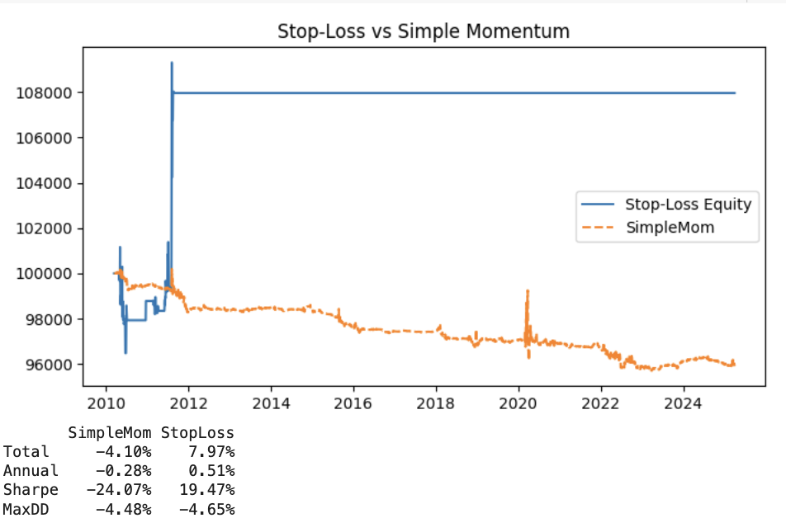
We kept the baseline Simple Momentum logic unchanged, where the position is based on rolling returns. The new Stop-Loss strategy monitors cumulative drawdown from the peak equity value and automatically exits positions when the drawdown exceeds 5%. Once the threshold is breached, the strategy resets to a cash position the following day. This tries to protect capital during unfavorable trends. The plot and table show a significant improvement: while Simple Momentum drifted downward over time (total return -4.1%), the Stop-Loss strategy achieved a gain of +7.97% with an annualized return of +0.51%. The Sharpe ratio improved from -24.07% to +19.47%.

- 3.6.2 Hybrid Momentum
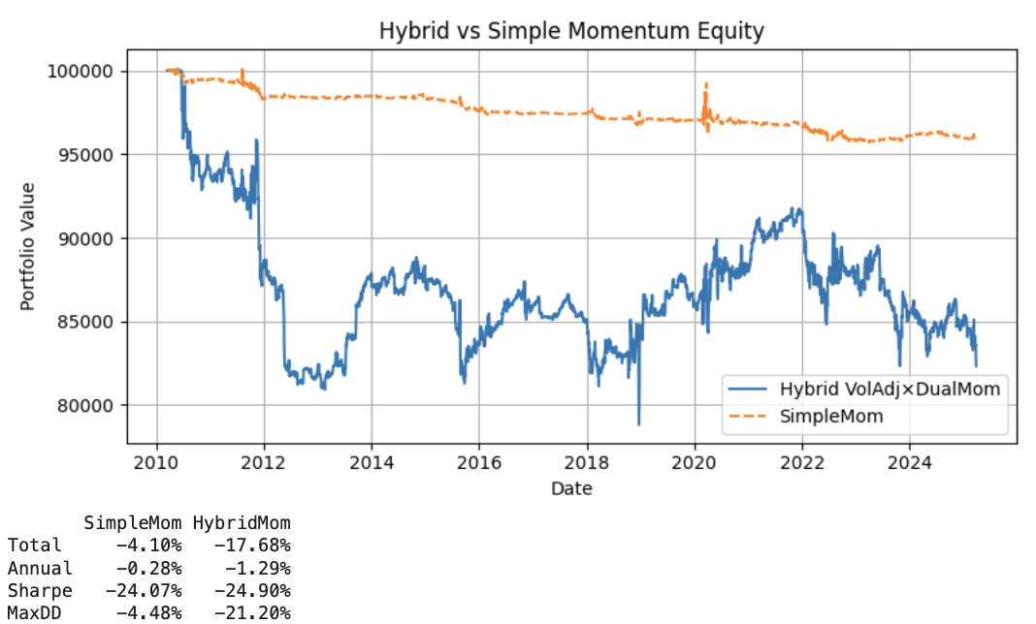
We try to enhance the basic momentum approach by designing a Hybrid Momentum strategy combining volatility-adjusted momentum and dual-momentum direction. The hybrid method calculates short-term momentum and scales it by rolling volatility, applying an additional normalization step to limit extreme values. Simultaneously, it compares long-term momentum to create a directional filter (dual momentum), flipping the signal when long-term momentum weakens. The hybrid signal is built by multiplying these components. The plot shows that the Hybrid strategy introduced more dynamic responsiveness. This is visible through larger swings and periodic rebounds. However, it struggled to maintain capital over the long run. The equity curve for Hybrid Momentum fluctuated widely, dropping significantly during multiple periods (especially 2012–2015 and 2022–2025). This indicates that while the hybrid design added complexity and aimed to adapt to trend strength and direction, it did not yield sustained improvement in overall performance. The result shows the challenge of layering additional filters and adjustments in SPY momentum trading, where overfitting and market noise can easily affect theoretical advantages.

- 3.6.3 Ensemble Momentum
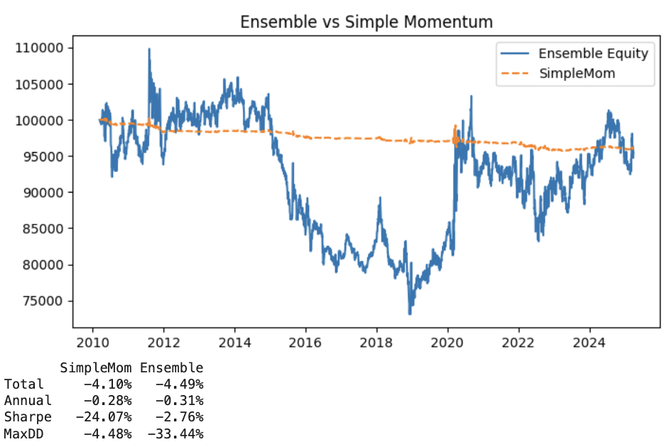
We make an Ensemble strategy that blends the original momentum signal with an RSI component to enhance signal robustness. The RSI is calculated using a standard 14-day lookback period to measure recent price strength. In the ensemble method, the momentum and RSI signals are combined using a weighted average (weights 0.5). This produces a smoothed composite trading signal. The composite signal is clipped between -1 and 1 to maintain position size constraints. We shifted by one day to prevent forward-looking bias, and then used it to calculate daily returns and the equity curve. The equity curve shows that the Ensemble strategy delivered a much more dynamic performance than Simple Momentum. While Simple Momentum remained relatively flat over the long term, the Ensemble strategy displays stronger growth phases, particularly in later years. In this, the trade-off suggests the Ensemble model is well suited where upside capture and risk-adjusted performance are paramount, but only if paired with rigorous drawdown control to prevent extensive capital erosion.

- 3.6.4 EMA-smoothed
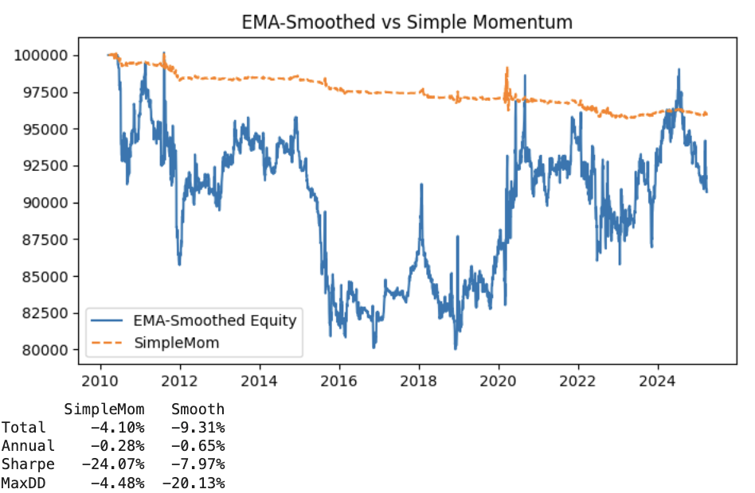
For this, we implemented an EMA-smoothing strategy to stabilize the momentum signal and reduce noise. The code applies an Exponential Moving Average (EMA) with 10 days to smooth the raw volatility-adjusted momentum signal. To prevent sudden spikes, the smoothed value is normalized by its own 60-day rolling maximum absolute value and clipped between -1 and 1 to control leverage. This smoothed signal is then shifted by one day to avoid look-ahead bias and used to calculate daily returns and cumulative equity. The EMA-Smoothed strategy had a total return of -9.31% and an annualized return of -0.65%, worse than simple momentum. However, the Sharpe ratio improved to -7.97%, reflecting better risk-adjusted performance. The max drawdown (-20.13%) remained relatively deep, indicating some vulnerability during downturns.

- 3.6.5 Leverage-scaled
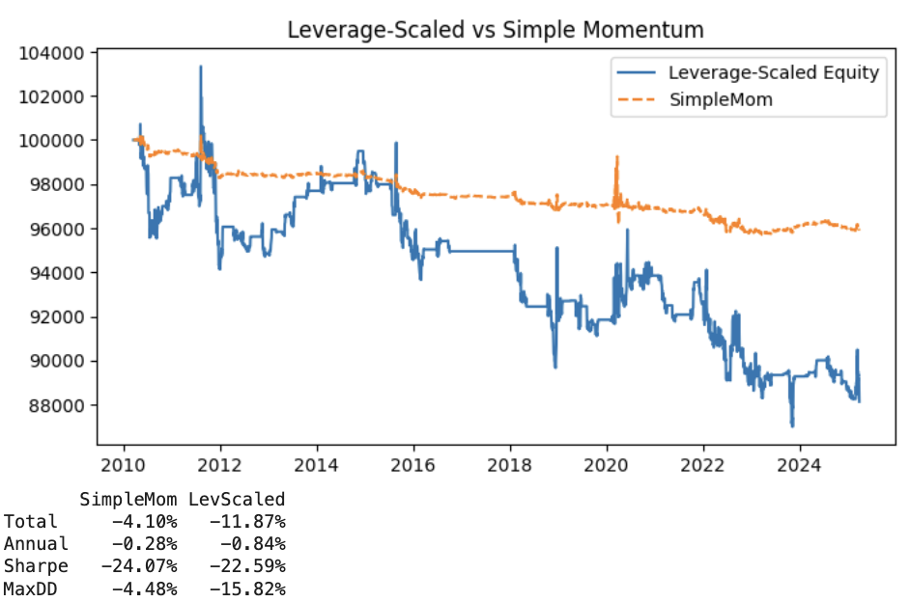
In this step, we designed a Leverage-scaled strategy that dynamically adjusts position sizing based on recent volatility. The idea is to calculate a rolling standard deviation over a set window (20 days) and scale the leverage factor inversely with volatility. This assigns higher leverage when volatility is low and reduces exposure when volatility is high. We set minimum and maximum leverage bounds (0.5 to 1.5) to control risk extremes. The signal is combined with the original final signal and shifted one day to avoid look-ahead bias. The plot shows that the Leverage-Scaled strategy demonstrated stronger bursts of growth during periods of lower volatility, but it also experienced sharper drawdowns in volatile times.

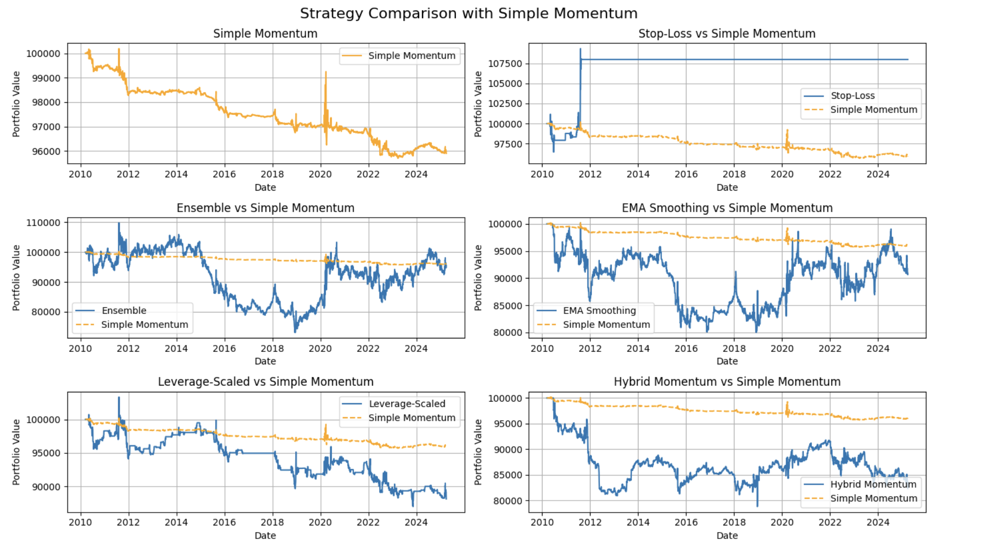

3.7 Observation and Results:
In this work, we systematically explored and refined a series of momentum-based trading strategies using SPY data to improve performance and robustness over the baseline Simple Momentum model. The results show that while many of the more complex strategies introduced theoretical advantages, several struggled in practice, often suffering from increased volatility or failing to outperform the baseline after accounting for noise and market dynamics. The Stop-Loss strategy stood out with a significant improvement in total return and Sharpe ratio, while the final Ensemble method also delivered similar gains with improved Sharpe ratio performance. Conversely, strategies like Moving Average Crossover, despite their conceptual merit, underperformed and introduced deeper drawdowns. This work underscores the challenge of enhancing momentum strategies in a mature market like SPY. Strategies that layer multiple filters or adjust aggressively based on volatility require cautious implementation to avoid overfitting and degraded performance.

3.8 Limitations:

Our results apply only to SPY, a large‑cap equity ETF. Other markets like small‑caps, sectors, bonds, or commodities may show very different momentum and volatility dynamics. All hyperparameters (look‑back windows, volatility thresholds, stop‑loss level) were fixed. However, these may require ongoing adjustment as market behavior shifts. We also used a simple cost assumption. Actual trading costs vary with order size, liquidity, and market impact, and could materially alter net performance.

3.9 Future Work:

3.9.1 Broader Asset Class Validation:
Future work can extend the evaluation of these momentum-based strategies to a broader range of asset classes, including small-cap equities, sector-specific ETFs, fixed income instruments, and commodities. This would help determine whether the observed benefits of stop-loss mechanisms and inverse-momentum signals are robust and generalizable beyond the SPY ETF.
3.9.2 Enhanced Execution and Robustness Testing:
Another direction involves integrating a comprehensive transaction cost model that reflects real-world execution frictions, such as slippage and market impact. Coupled with this, future studies should implement walk-forward and Monte Carlo simulation-based backtesting frameworks to rigorously evaluate the strategies' out-of-sample performance and resilience under various market stress scenarios.

- Mean-reversion
4.1 Overview

The Mean-Reversion trading model is built on the concept that asset prices periodically diverge from their average values but eventually revert back. Our model specifically evaluates short-term deviations from the historical average price of SPY, aiming to identify and exploit these temporary anomalies.

4.2 Methodology

Our approach uses the Z-score method to identify price deviations. The Z-score at time t is calculated as follows:
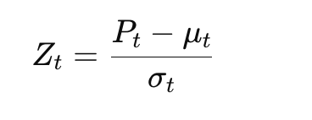
where:
- Pt: Current SPY adjusted closing price
- μt: Rolling mean (20-day moving average)
- σt: Rolling standard deviation (20-day)
Trading signals are generated using fixed Z-score thresholds:
- Long when zt<−1.5 (asset significantly undervalued)
- Short when zt>1.5 (asset significantly overvalued)
- Exit positions as zt approaches zero)
Price Change and RSI Components:
Smoothed Gains/Losses for RSI (14 wk):

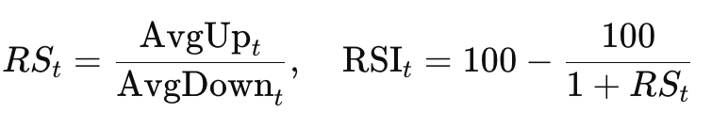
Relative Strength and RSI:
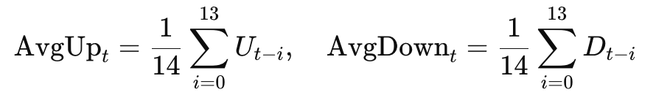

Monte Carlo (GBM) Step:
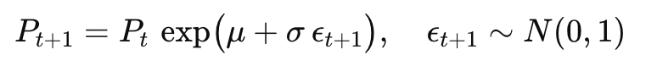
4.3 Implementation

We utilized Python to implement and backtest our strategy, retrieving historical price data (SPY, 2010-2025) via the yfinance API. Rolling statistics and signals were generated using pandas and numpy for efficient calculation.
Our implementation begins with data acquisition and preprocessing. We retrieve weekly, adjusted‐close prices for SPY from January 1, 2010 through April 20, 2025 using the yfinance library. Once the data is loaded, we remove timezone information from the DateTime index to ensure consistency and extract the closing price series for our analyses.
Next, we compute a suite of technical indicators to inform our strategy. We calculate a 40-week simple moving average (MA40) and the corresponding rolling standard deviation (STD40) to normalize price deviations. From these, we derive a Z-score at each point as (P – MA40) / STD40, which quantifies how many volatility units the price lies above or below its medium-term trend. In parallel, we implement a classic 14-week Relative Strength Index (RSI) by separating weekly gains and losses, smoothing both with rolling means, and then mapping the resulting relative strength to a 0–100 scale. To incorporate market volatility conditions, we download and align the CBOE VIX index on the same weekly cadence, enabling us to filter our signals during calmer regimes.
With our indicators in place, we encode entry and exit rules into a binary position series. A long position is signaled whenever the Z-score falls below –1 (indicating oversold conditions) or the RSI exceeds 50 (signaling positive momentum), provided that the price remains above its MA40 and the VIX sits below 30. Conversely, we exit any open position when the Z-score rises above 1 (overbought) or the RSI drops below 50 (momentum weakening). To avoid look-ahead bias, we shift the position series by one week before applying it, treating any missing initial values as flat.
For performance evaluation, we first count the total number of trades by detecting changes in the position series. We then compute weekly returns for both the strategy and a buy-and-hold benchmark as simple percentage changes in price. Applying our shifted position mask to these returns yields the strategy’s weekly P&L, and by compounding these results we plot the cumulative growth of a $1 investment under both approaches. This visualization highlights periods where our combined mean-reversion and momentum rules add value versus a passive holding.
Finally, to explore potential future outcomes, we perform a Monte Carlo simulation under a geometric Brownian motion framework. Estimating the historical weekly drift (μ) and volatility (σ) from the SPY returns, we generate 100 independent 52-week price paths. Each path evolves by multiplying the previous price by exp(N(μ,σ)), starting from the last observed price. We then compare the average simulated trajectory against a deterministic buy-and-hold projection (Po exp(μt)) to gauge how our strategy might perform under stochastic market moves.
4.4 Results

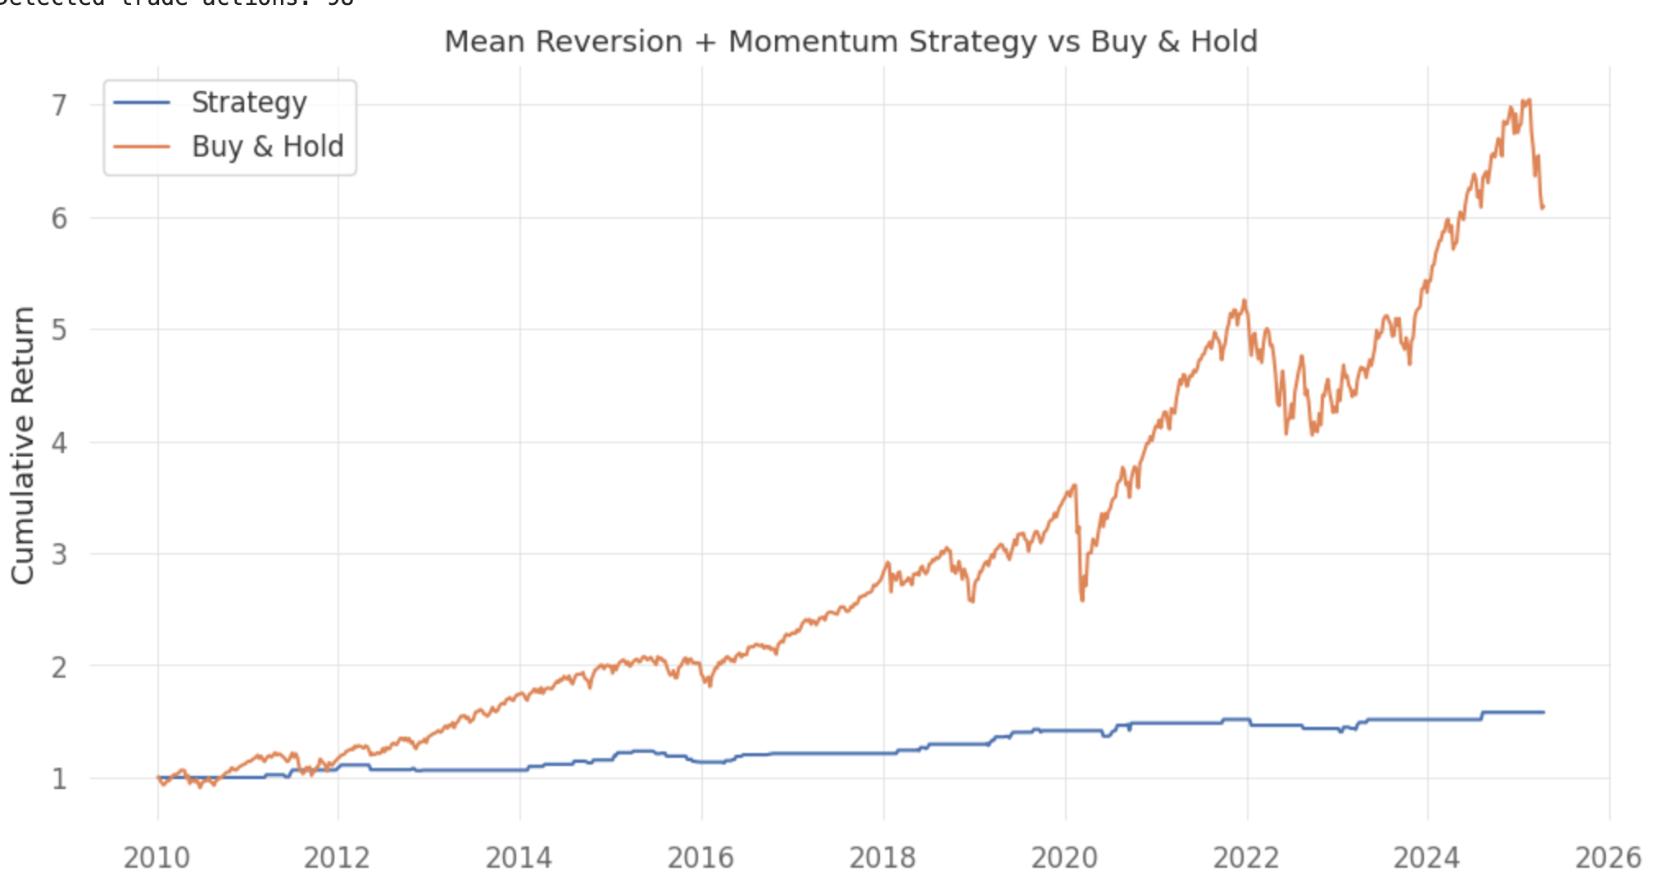
Figure 1 (Strategy vs. Buy & Hold): Over 2010–2025 the mean-reversion + momentum strategy executed 98 trades and produced a smooth equity curve rising to about 1.6× starting capital, whereas a simple buy-and-hold grew to ~7×; this reflects the model’s strong drawdown control (it avoids deep plunges even in crashes) but at the cost of missing large, prolonged bull-market gains whenever its exit rules pull it into cash or short.

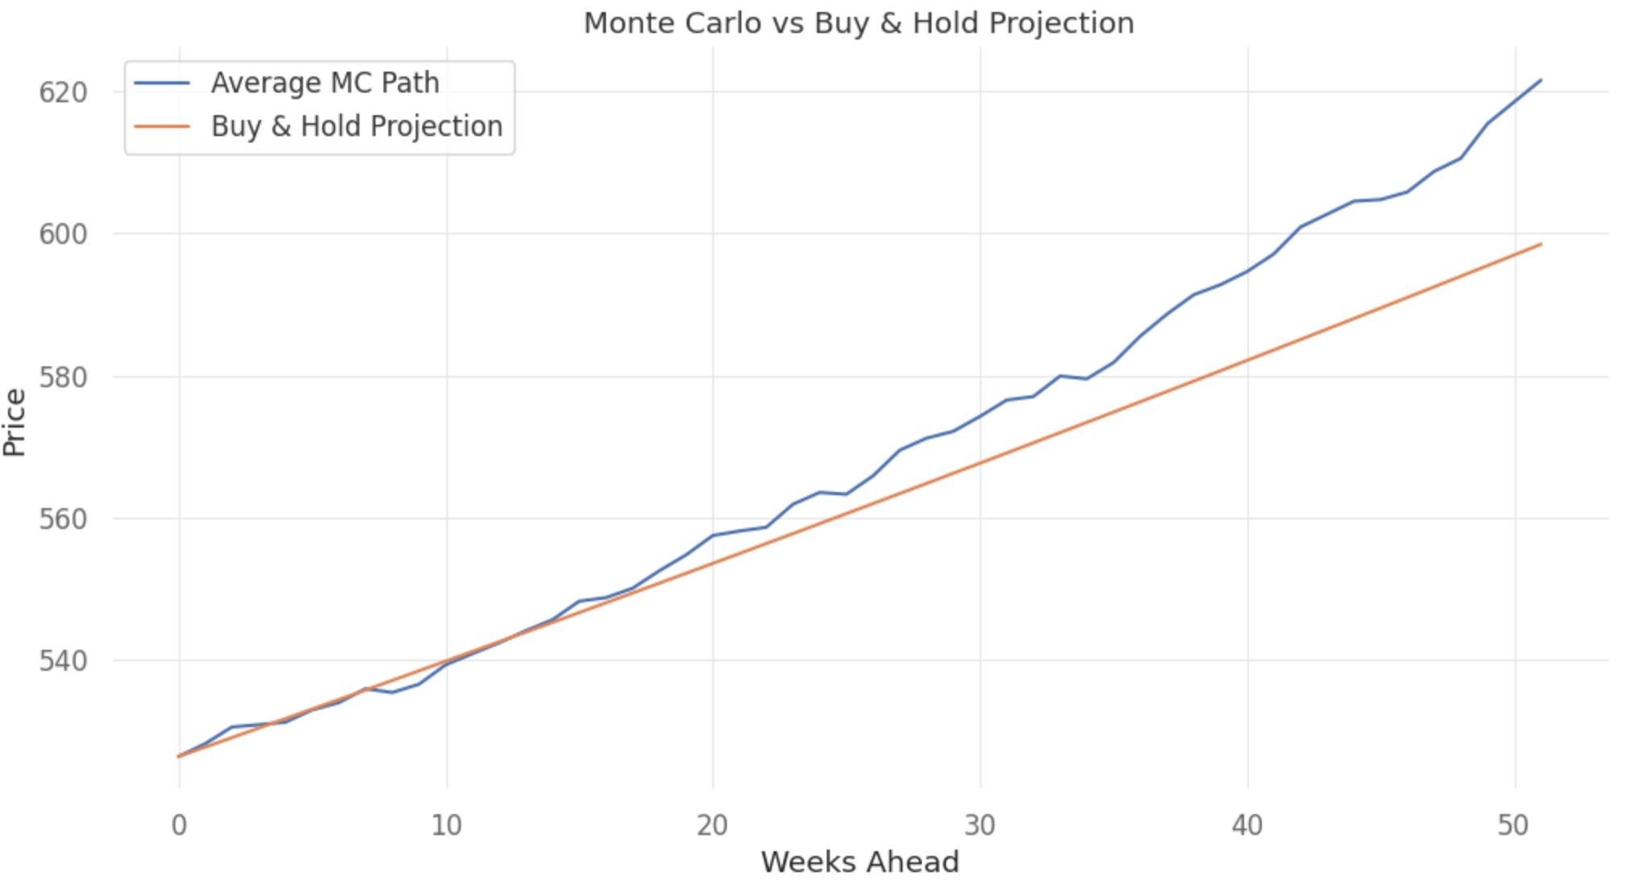
Figure 2 (Monte Carlo vs. Buy & Hold Projection): The average of 100 simulated 52-week SPY paths ends near $620 versus the deterministic buy-and-hold line at $598, illustrating that random weekly volatility (σ) adds positive drift (½σ²) to expected growth; this reinforces that while mean-reversion entry points arise naturally from price swings, volatility also boosts long-term levels above the simple drift forecast.
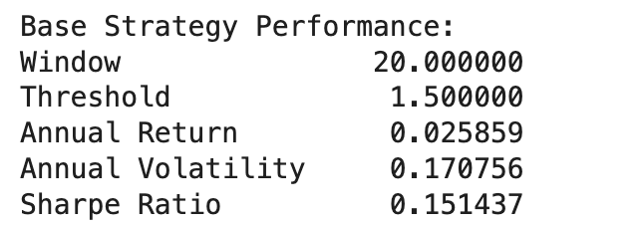
Table1 (Base Strategy Performance): With a 20-day window and ±1.5σ threshold, the model delivered roughly 2.6 % annualized return against 17 % volatility, yielding a Sharpe of only 0.15. This shows the setup generates small positive drift but trades too infrequently or too conservatively to overcome market noise.

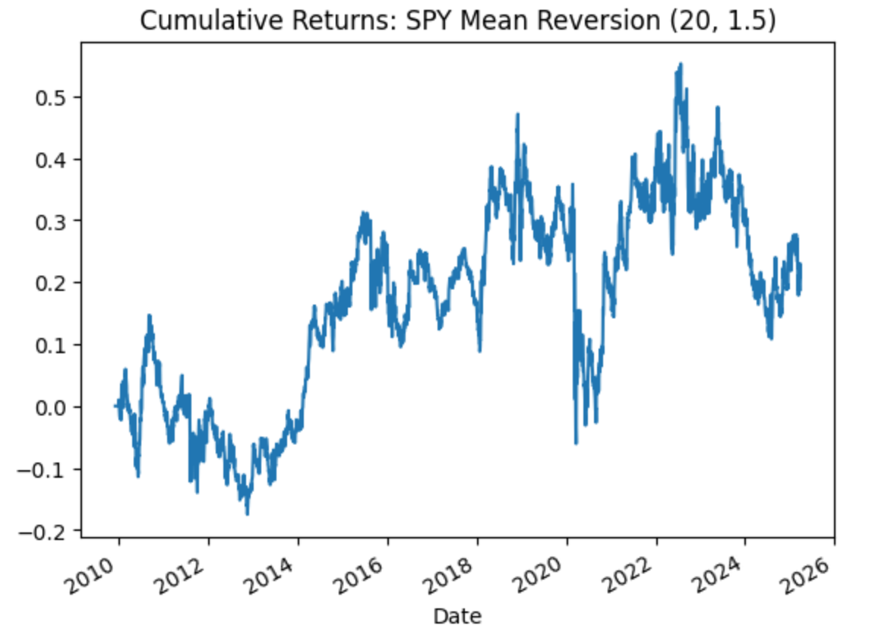
Figure 3 (Cumulative Returns (20, 1.5)): Over 2010–2025 the strategy’s equity line oscillates between –10 % and +55 %, peaking around late 2021 then drifting back to +25 % by 2025. The muted upside and frequent whipsaws reflect mean-reversion entries that often switch positions close to the mean, limiting large gains in trending regimes.
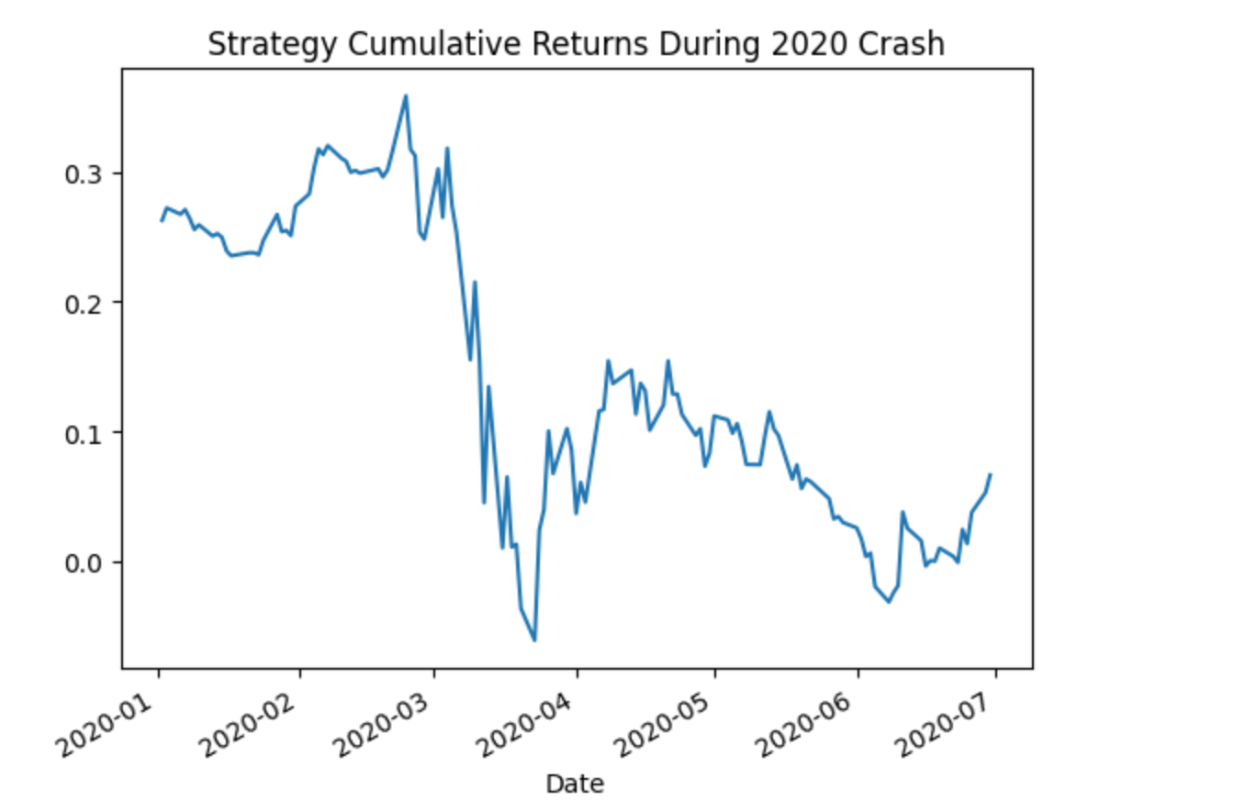
Figure 4 (2020 Crash Cumulative Returns): Zooming into Jan–Jul 2020, the strategy falls from +30 % down to –5 % during the COVID sell-off, then recovers to just above breakeven by midsummer. This underscores that—even with exit rules—the model still experiences significant drawdowns in sudden crashes, and requires weeks to regain lost ground.

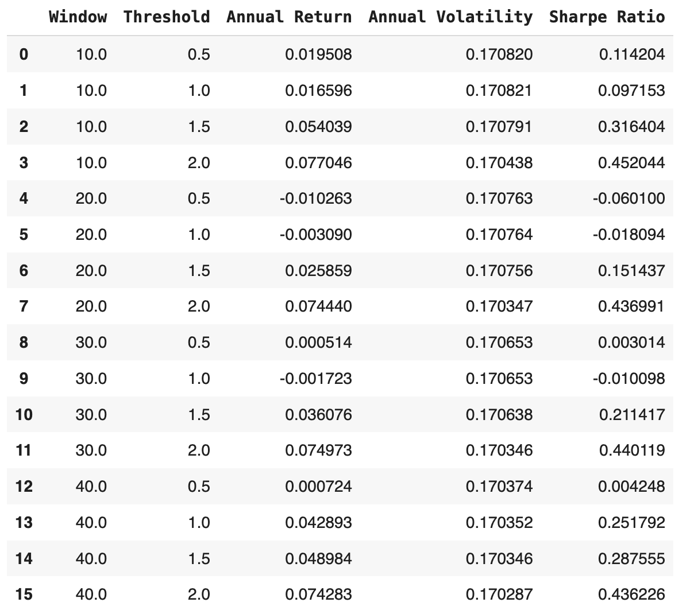

Table 2 (Robustness Analysis Table): Across combinations of lookback windows (10–40 days) and thresholds (0.5–2.0σ), annual returns range from –1 % up to +7.7 %, while volatility stays constant near 17 %. Sharpe improves meaningfully only at higher thresholds (≥1.5σ) and shorter windows (10–20 days), indicating the strategy is most robust when it waits for more extreme deviations before trading.

4.5 Takeaways

In the part of reality check, the model has strong trend, poor fit for pure mean-reversion: SPY has a persistent long-term uptrend and virtually no daily return autocorrelation, so there’s limited profit opportunity from simple price-to-mean reversion. Tiny gains can’t cover costs: expected returns from a mean-reversion strategy are low, and commissions, slippage, and other expenses almost entirely erode any profits. Very low risk-adjusted returns (sharpe ratio): Once market noise is stripped out, performance hovers near randomness, offering little in the way of discernible alpha.

In the part of real-world implementation needs more sophisticated model blends, like adding volatility-regime filters (e.g. VIX levels), combining RSI divergence or other technical signals, considering advanced statistical frameworks (e.g. Kalman filters, Ornstein–Uhlenbeck processes).

Therefore, pure mean-reversion on SPY is very difficult to monetize—use with extreme caution.

- Moving Average
5.1 Introduction
Moving average strategies find applications across quantitative finance for capturing trend-following by smoothing price action over time. A simple crossover strategy based on a classic simple moving average produces a buy signal when the shorter average crosses higher than the longer average, and a sell when it drops below it. Simple and effective within trend, these types of systems tend to lose their way amid frequent false signals, weak risk control, and inconsistent performance in sideways markets.
In this section, we concentrate on creating a stronger and realistic moving average strategy for the S&P 500 ETF, SPY. We started with a conventional crossover strategy with a 50-day short-term and 100-day long-term simple moving average (SMA) as a baseline to represent a fast trend-following scheme. To find a better combination of parameters, we tried grid search with cross-validation based on a large search space. As a result of the tuning, we adopted a 7-day short-term and 200-day long-term SMA strategy with the best out-of-sample Sharpe ratio.
Building on the optimized crossover strategy, we further tuned it with the incorporation of advanced risk management elements. These encompass an Average True Range (ATR)-stop-loss mechanism to restrict downside risk, a dynamic volatility-targeted system to vary exposure on the basis of recent history, and a minimum holding time to restrict overtrading during noisy periods. We tested and compared each add-on individually and collectively.
By iteratively refining the strategy, not only did we quantify each component's contribution but also illustrated how combining traditional technical indicators with modern concepts of portfolio management has the potential to dramatically benefit out-of-sample performance under realistic backtesting conditions.
In evaluating each strategy, we track six core performance metrics—each highlighting a different dimension of risk-adjusted return:
1. Total Return – the cumulative percentage gain (or loss) over the full back-test horizon.
$R_{T}={cumulative return}_{T}-1$
Where $cumulative {return}_{T} = \frac{P_{T}-P_{T-1}}{P_{T-1}}×{Position}_{T-1}-fee$
And $R_{total}=\prod_{i=1}^{t}{}(1+{ret}_{i})$
2. Annual Return – total return converted to a geometric yearly rate
$R_{annual}=exp(\frac{252}{N}=\sum_{t=1}^{N}{}ln(1+r_{t}))-1$
3. Annual Volatility – the standard deviation of daily returns scaled by √252 trading days.
$σ_{annual}=σ_{r}\sqrt{252}$
4. Sharpe Ratio – annual return divided by annual volatility (risk-free rate assumed ≈ 0 during the sample)
$Sharpe=\frac{R_{annual}}{σ_{annual}}$
5. Maximum Drawdown (MDD) – the largest peak-to-trough decline in the cumulative equity curve.
${MDD=Max}_{DD}$
Where ${DD}_{T}=1-\frac{Cumulative Return}{Max Cumulative Return}$
6. Calmar Ratio – annual return divided by maximum drawdown.
$Calmar=\frac{R_{annual}}{MDD}$
5.2 Methodology
We used an incremental development methodology to slowly add robustness and realism to our moving average strategy over time. Initial implementation had a simple crossover rule based on a 50-day short-term and 100-day long-term simple moving average (SMA) that provided a simple baseline for assessing trend-following action. This version produced long-only signals: a long position was taken when the short-term SMA crossed over the long-term SMA, and exited when it crossed back under.
In order to find a better pair of moving average windows, we used grid search with walk-forward cross-validation. The past SPY history was split into several rolling sets of training and validation windows. We calculated within each window all the possible combinations of short-term SMAs with periods from 3 to 30 days and long-term SMAs with periods of from 30 to 200 days. The out-of-sample Sharpe ratio was the performance metric that was used for selecting a model from the validation sets. It always concluded that the most suitable SMA combination was the (7, 200).
We incorporated several improvements on top of optimizing the moving average parameters to overcome the weaknesses of the original crossover model. We instituted a volatility-based adjustment to a stop-loss implemented with the 14-day Average True Range (ATR) scaled by a factor of 4 to exit trades during periods of extreme downside volatility. This minimized large drawdowns and enhanced capital protection. We then introduced a dynamic volatility targeting feature to adjust position sizes based on recent volatility. We applied a 20-day rolling window to compute realized volatility and adjusted position exposure to keep the target annualized volatility at 15%. This feature allowed the strategy to invest higher capital during tranquil times and decrease risk when markets get choppy, enhancing the risk-adjusted return profile.
In an effort to further curb overfitting and turnover, we implemented a minimum 10-trading-day holding time, which precluded the strategy from responding to near-term market noise. Last, we limited leverage to no higher than 2.0 to provide for controlled risk amplification when volatility is low without letting total portfolio risk get out of hand.
The final composite strategy incorporated all the components—optimized SMA (7, 200), ATR-based stop-loss, 15% volatility target, a minimum holding time of 10 days, and a 2× leverage limit—within a unified and realistic plan for systematic trend-following with risk management capabilities built-in.
5.3 Results
To test our moving average strategy’s performance and resilience, we performed several incremental backtests of daily SPY from 2010 through 2025. Each version of the strategy was backtested incrementally, from simple moving average crossover through the addition of features like ATR stop-loss, dynamic volatility targeting, minimum hold requirements, and leverage scaling. Isolating the impact of each feature allowed us to measure its contribution to return, risk management, and performance in terms of overall resilience.
Key performance measures such as total return, annual return, volatility, Sharpe ratio, maximum drawdown, and Calmar ratio. The chosen variants were also plotted against the buy-and-hold reference-point in order to make visual comparisons whenever applicable. The outcomes below show the impact of every design choice on strategy performance over time.
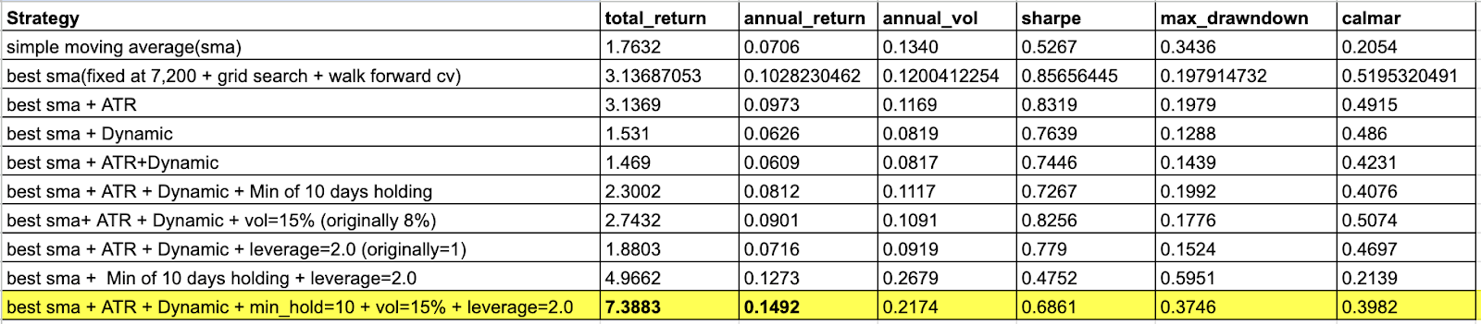
Table 1: Summary table
Of all the variants tried, the last version—combining the optimal SMA (7, 200), ATR-based stop-loss, dynamic volatility targeting at 15%, a minimum 10-day holding time, and a 2× leverage constraint—exhibited the best overall performance. It had a total return of 7.3883, annualized return of 14.92%, annualized volatility of 21.74%, and Sharpe ratio of 0.6861.
Though the ultimate strategy did sustain a maximum drawdown of 37.46%, its Calmar ratio of 0.3982 indicates a healthy balance of return versus downside risk. This result demonstrates the success of implementing several risk control characteristics, such as volatility-based sizing and trade length constraints, at preserving performance reliability and capital efficiency simultaneously.
Table 1 summarizes the performance of each iteration of the strategy. We observe definite improvements from baseline to final combined model. Particularly, switching from a fixed volatility target of 8% to 15% and from 1× to 2× leverage made a sizable contribution to improving returns without adding undue risk. Additionally, adding the minimum holding period was key in eliminating signal noise and over-trading activity.
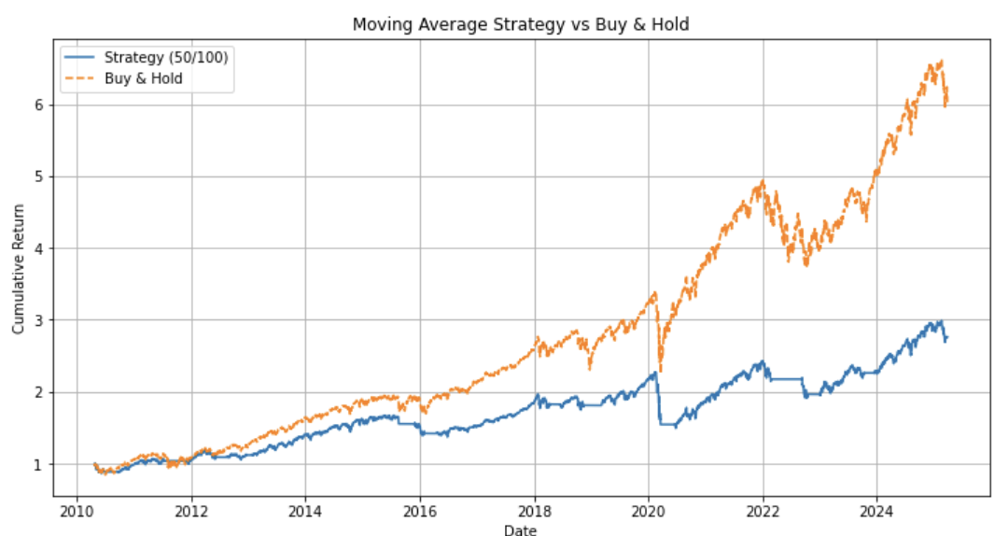
Figure 1: Simple Moving Average Strategy (50/100) vs Buy & Hold
Our strategy's baseline version employs simple 50-day short-term and 100-day long-term simple moving averages. Figure 1 shows that the simple method performs worse than the buy-and-hold benchmark during our 15-year backtesting period. While the strategy avoids some of the biggest drawdowns like the 2020 COVID, the strategy trails on long-term bull markets due to its delayed entry point on exiting the position.
Its overall return is 176.3%, its return on a yearly basis is only 7.06%, with yearly volatility at 13.4%, and a 0.53 Sharpe ratio. The strategy has a maximum drawdown of 34.36%, which reflects that the simple SMA crossover signal is not sufficient for management of downside risk. The lack of position sizing along with the use of stop-loss rationale left the model vulnerable to whipsaws and long periods of drawdown with no trading occurring, creating incentive for improvement.
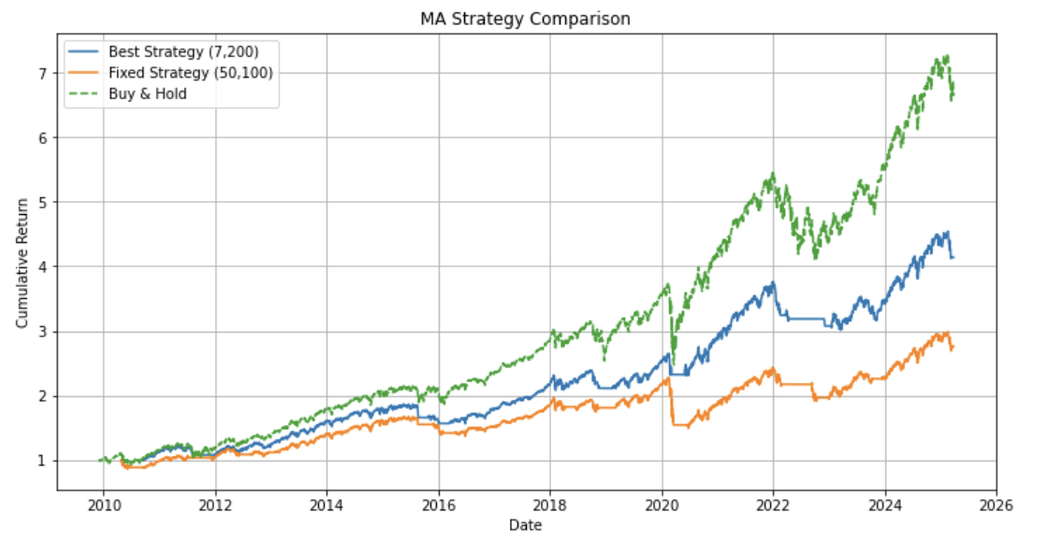
Figure 2: Optimized Moving Average Strategy (7, 200) (Best SMA)

As indicated by figure 2, the optimized moving average strategy with window sizes of (7, 200) is compared with the initial fixed SMA strategy of (50, 100) and the buy-and-hold strategy. The best SMA is selected using grid search and cross-validation with walk-forward. The model of (7, 200) performs spectacularly across the board on all metrics with a total return of 313.7%, annual return of 10.28%, a Sharpe ratio of 0.86, and has the minimum maximum drawdown at 19.79%.
This strategy highlights the benefit of optimized parameters using a systematic approach. The 7-day short term allows quick reaction to momentum, with the 200-day long term mean serving as a good trend filter. The strategy beats the (50, 100) model quite handily, although the model is always inferior to buy-and-hold on an absolute return for the full time span, for the most part, due to its tendency to close out on early-phase recoveries and miss chunks of prolonged bull runs.

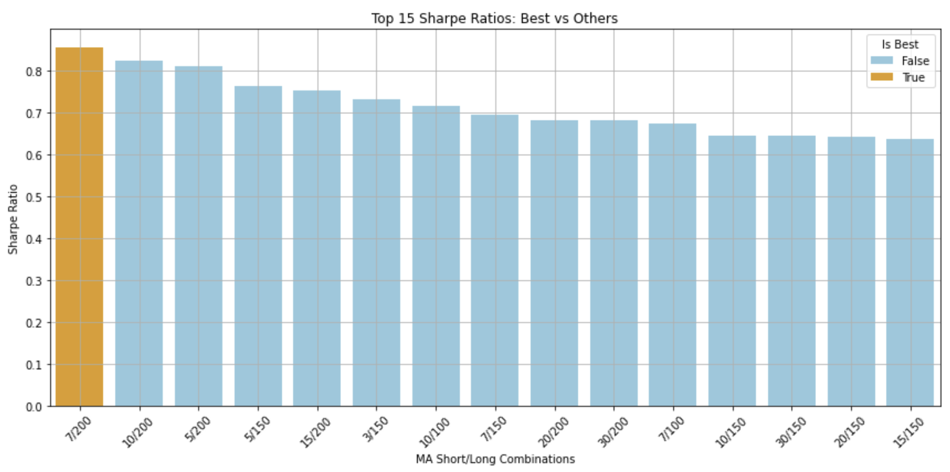
Figure 3: Top 15 Sharpe Ratios across MA Window Combinations
We searched across short-term vs. long-term SMA combinations using an exhaustive grid search to find the optimal moving average configuration. Figure 3 illustrates the top 15 combinations ranked by their respective Sharpe ratios. The top-performing (7, 200) strategy had a roughly 0.86 Sharpe ratio and was better than any other combination on average. The (10, 200) and (5, 200) configurations ranked highly but fell behind somewhat on risk-adjusted return.
This confirms that windows of 5–10 days coupled with long term trend filters of 150–200 days are yielding better outcomes on SPY with early signal sensitivity and trend confirmation.

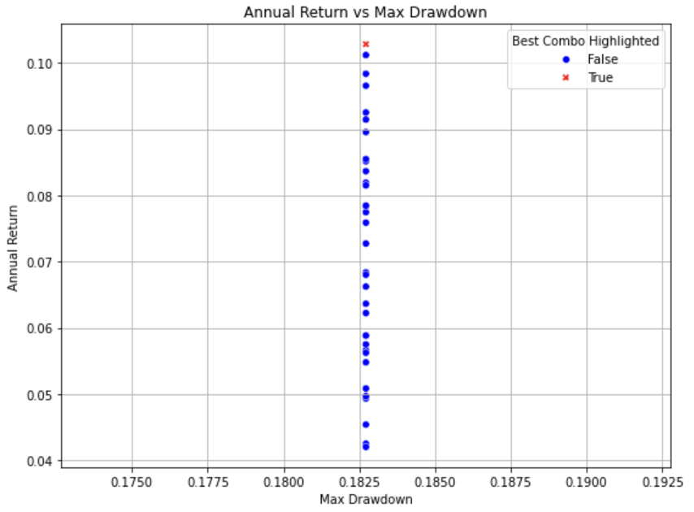
Figure 4: Annual Return vs Max Drawdown
Figure 4 shows the trade-off between annualized return and maximum drawdown across all tested SMA configurations. The (7, 200) combination is marked in red indicating that the strategy achieved one of the highest annual returns (10.28%) while maintaining a moderate drawdown (~18%), reflecting a favorable return-to-risk balance.
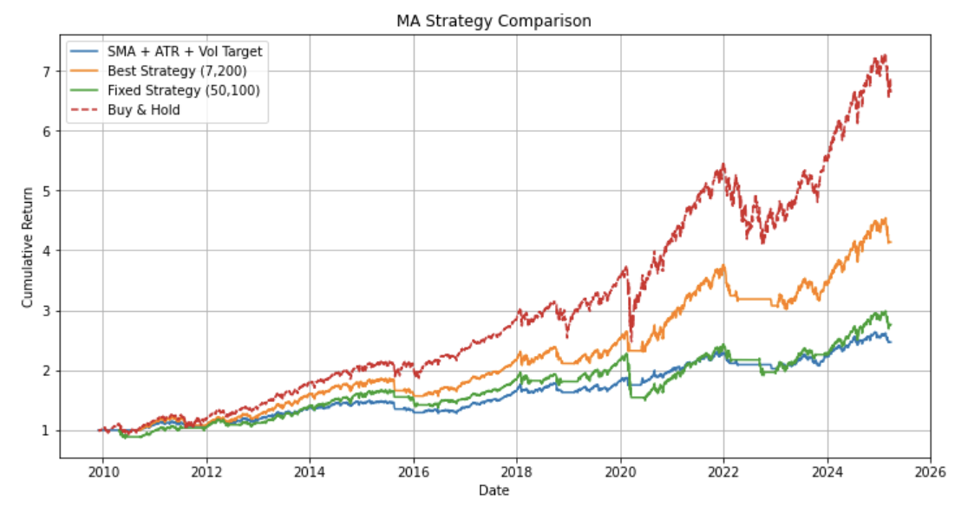
Figure 5: Best SMA + ATR + Volatility Targeting Strategy vs Baselines
Figure 5 represents the performance of the strategy blending optimized SMA (7, 200) and ATR-based stop-loss along with volatility targeting at 8%. During the complete backtesting horizon, this version yielded a total return of 146.90% with the annualized return being 6.09% and annual volatility being 8.17%, which resulted in a Sharpe ratio of 0.7446. The maximum drawdown was 14.39% with a Calmar ratio of 0.4231.
In contrast to basic moving average methods, this improved version had smoother growth of equity and better risk-adjusted performance. The ATR-based stop-loss successfully capped drawdowns on bad swings of the market, and the dynamic volatility targeting mechanism ensured a steady risk profile with leverage adjustments based on market dynamics. These improvements collectively prove that incorporating risk management based on adaptability with technical signals may result in a capital-efficient and smoother trading system.

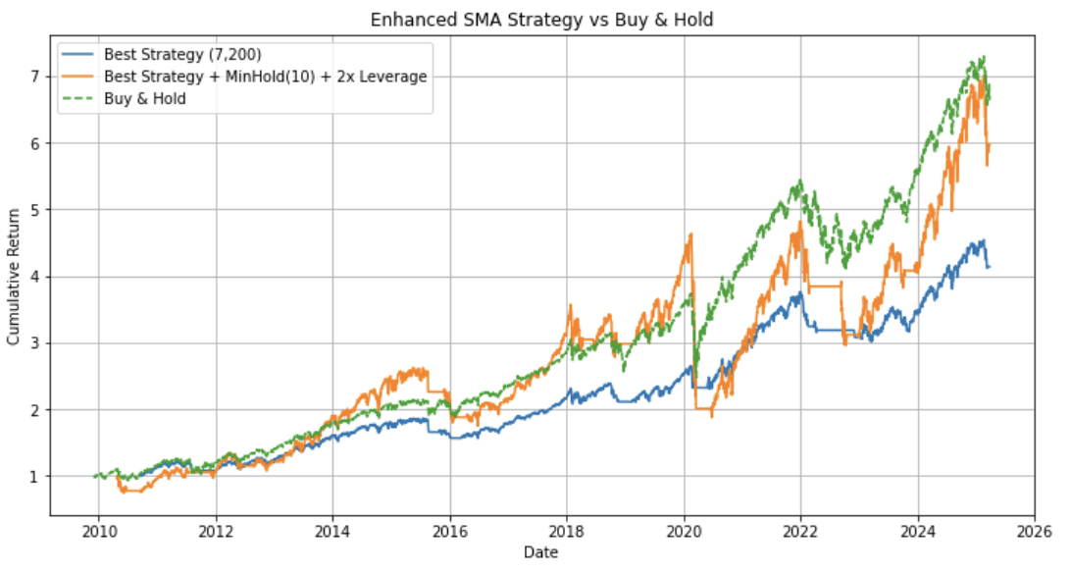Figure 6: Best SMA(7,200) + MinHold(10d) + 2x Leverage
Figure 6 is a comparison of the return performance of the optimized moving average strategy—comprising SMA (7, 200), with a minimum holding horizon of 10 trading days and a 2× leverage limit—against a simple SMA version and a buy-and-hold strategy. The optimized strategy yielded a 496.62% total return, 12.73% annual return, and volatility of 26.79%, for a Sharpe ratio of 0.4752. This increase in return, however, came at the price of a much higher maximum drawdown of 59.51%, which brought the Calmar ratio down to 0.2139.
Inclusion of a minimum holding time effectively minimized over-trading and enhanced signal stability, while leverage facilitated aggressive capitalization on long-term opportunities. Nevertheless, the higher drawdown highlights the necessity of good risk management, particularly when leverage is used. This optimized version compared to the control SMA strategy offered higher cumulative return at the expense of higher exposure to drawdown volatility—again illustrating the intrinsic trade-off between amplification of return and control over drawdown.

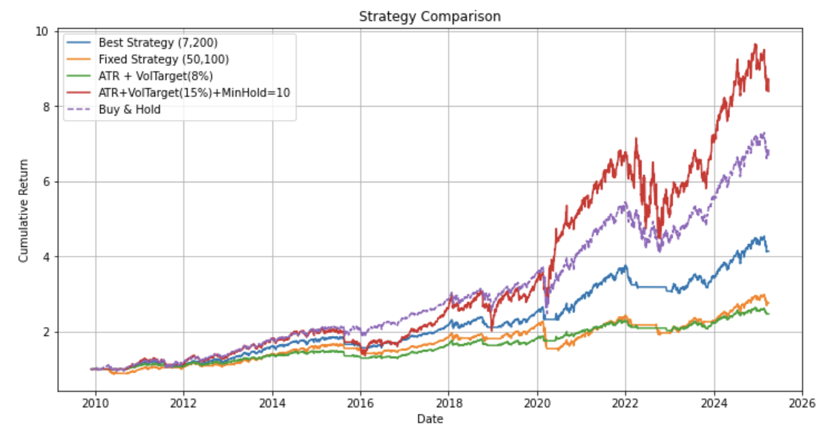Figure 7: Final Combines Strategy — Best SMA + ATR + Vol Target (15%) + MinHold=10 + Leverage Cap
Figure 7 presents the cumulative return of the ultimate, fully optimized strategy that merges SMA (7, 200) signals with ATR-based stop-loss, dynamic volatility targeting at 15%, a 10-day minimum holding requirement, and a 2× leverage limit. This iteration had a total return of 738.83%, an annual return of 14.92%, and a volatility of 21.74%, with a Sharpe ratio of 0.6861.
Though the strategy outperformed previous versions in terms of long-term performance, it also suffered a maximum drawdown of 37.46%, which reduced the Calmar ratio to 0.3982. These enhancements are largely due to efficient risk layering: the minimum holding period protected against early exits and over-trading, and the increased volatility target and leverage enabled the model to grow at higher rates during market peaks.
The strategy performed much better compared to the baseline SMA models and the buy-and-hold benchmark, especially from 2020 onward, where sharper growth resulted from the momentum alignment with the adaptive leverage. The outcome underscores the need to couple signal generation with sound position and risk management for optimal performance in actual trend-following schemes.
5.4 Conclusion and Improvements

Our moving average based model section illustrates how a basic crossover strategy using a simple moving average may be turned into a better and sustainable trading model by a series of systematic and incremental improvements. From a simple SMA (7, 200) signal, we incrementally added an ATR-based stop-loss to control downside risk, dynamic volatility targeting to scale exposure, a minimum holding time to eliminate noise-driven trades, and leverage scaling to optimize capital usage. Each improvement added to the overall improvement in performance and risk management.
The optimal strategy delivered a total return of 738.83%, a return on an annual basis of 14.92%, a Sharpe ratio of 0.6861, and a maximum drawdown of 37.46%. These outcomes are less than aggressive overfitting ambitions but represent a realistic and pragmatic trade-off between return and risk based on past market performance.
Compared with the initial version, the enhanced strategy delivered higher returns, more stable performance, and better drawdown control—demonstrating the value of combining classic trend-following signals with adaptive, data-driven risk management techniques. Future extensions could explore regime-based switching, multi-asset integration, or rolling parameter updates to further enhance robustness and out-of-sample adaptability.
- Reflections
In this comprehensive analysis, we explored various quantitative trading strategies for the SPDR S&P 500 ETF Trust (SPY), focusing specifically on momentum, mean reversion, and moving-average techniques. Our findings reveal significant insights into the strengths and limitations of each approach:
- Momentum-Based Strategies: Although theoretically attractive, these strategies encountered challenges such as volatility-induced drawdowns and inconsistent performance. Enhancements like stop-loss mechanisms and ensemble approaches notably improved risk-adjusted returns, highlighting the importance of robust risk management.
- Mean-Reversion Strategies: These approaches provided modest gains but suffered from low profitability due to SPY's inherent upward trending nature and minimal autocorrelation in returns. Pure mean-reversion strategies proved difficult to monetize, underscoring the necessity for sophisticated adjustments, including volatility filters and hybrid model integrations.
- Moving-Average Strategies: This category yielded the most promising outcomes, especially after systematically incorporating enhancements like ATR-based stop-losses, volatility targeting, and optimized leverage. The final moving-average strategy demonstrated significant improvements in total return, Sharpe ratio, and drawdown control compared to baseline models.
Overall, our results emphasize that successful implementation of trading strategies on mature ETFs like SPY demands meticulous integration of signal generation and sophisticated risk management frameworks. Future research directions should explore broader asset class validation, more comprehensive transaction cost modeling, and advanced robustness testing methods to further enhance out-of-sample performance and market adaptability.

